7th-12th Grade Literacy Bag Blue ($5) Total Replacement: ($80)
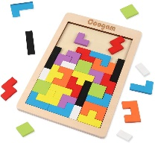
Puzzle –($10)

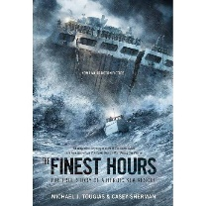

The Finest Hours –($7)



And Still I Rise: A Book of Poems –($13)

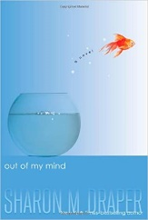

Out of My Mind –($9)
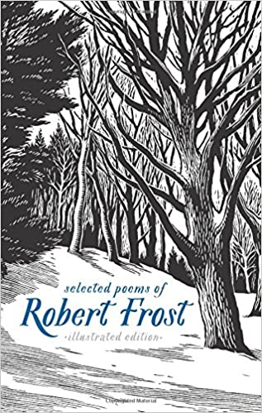

Selected Poems of Robert Frost: Illustrated Edition –($17)



All Quiet on the Western Front: A Novel –($7)

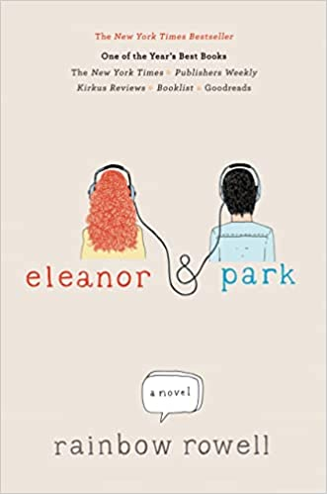

Eleanor & Park –($12)

Literacy Kit
7th-12th Grade Literacy Bag Blue ($5) Total Replacement: ($80)

West Hempstead Library Adult Cardholders in good standing.
Loan Period- 14 day.
$2.00 a day late fee (not including Sundays)
If taken out on a Sunday, Bag is due back the following Monday.
No Reservations: First Come, First Serve

Puzzle –($10)
The Finest Hours –($7)
And Still I Rise: A Book of Poems –($13)
Out of My Mind –($9)
Selected Poems of Robert Frost: Illustrated Edition –($17)
All Quiet on the Western Front: A Novel –($7)
Eleanor & Park –($12)

___________________________ ___________________________
Library Card Holder Name Signature

___________________________
Library Card Number

___________________________ ___________________________
Date of Check Out Due Date

