B-K Literacy Bag Blue ($5) Total Replacement ($67)

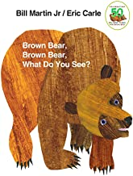

Brown Bear, Brown Bear Board Book – ($5)

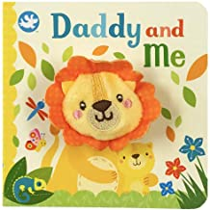

Daddy and Me- Lion Puppet Book- ($7)

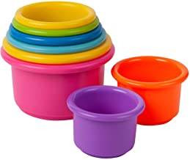

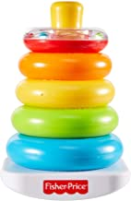8- stackable cups ($5)

Fisher Price Stackable Rings ($5)

My First Book of: ($17)

1. Transport
2. Vegetables
3. Fruits
4. Birds
5. Shapes
6. Wild animals
7. Colors farm animals & pets
8. Numbers
9. Abc
10. Colors

Jigsaw Puzzle ($10)

1. Crab
2. Butterfly

Mathematics Match it- ($13)

Literacy Kit  
B-K Literacy Bag Blue ($5) Total Replacement ($67)

West Hempstead Library **Adult** Cardholders in **good standing**.

Loan Period- 14 day.

$2.00 a day late fee (not including Sundays)

If taken out on a Sunday, Bag is due back the following Monday.

No Reservations: First Come, First Serve

Brown Bear, Brown Bear Board Book – ($5)  
Daddy and Me- Lion Puppet Book- ($7)  
8- stackable cups ($5)  
Fisher Price Stackable Rings ($5)  
My First Book of: ($17)

1. Transport _____
2. Vegetables _____
3. Fruits _____
4. Birds _____
5. Shapes _____
6. Wild animals _____
7. Colors farm animals & pets _____
8. Numbers _____
9. Abc _____
10. Colors _____

Jigsaw Puzzle ($10)

Pout Pout Fish Board Book ($5)

Mommy and Me - elephant puppet book ($7)

8- stackable cups ($5)

Fisher Price Stackable Rings ($5)

My First Book of: ($17)

1. Food
2. Flowers
3. About me
4. Opposites
5. Baby objects
6. Baby animals
7. Toys
8. People at work
9. Things at home
10. Sea animals

Jigsaw Puzzle ($10)

1. Ladybug
2. Bear

Mathematics Match it- ($13)

1. Crab _____
2. Butterfly _____

Mathematics Match it- ($13)

Pout Pout Fish Board Book ($5)

Mommy and Me - elephant puppet book ($7)

8- stackable cups ($5)

Fisher Price Stackable Rings ($5)

My First Book of: ($17)

1. Food
2. Flowers
3. About me
4. Opposites
5. Baby objects
6. Baby animals
7. Toys
8. People at work
9. Things at home
10. Sea animals

Jigsaw Puzzle ($10)

1. Ladybug
2. Bear

Mathematics Match it- ($13)

___________________________ ­­­­­­­­­­­­­­­­­­­­­­­­­___________________________

Library Card Holder Name Signature

___________________________

Library Card Number

___________________________ ___________________________

Date of Check Out Due Date